Enabling Reporting Services on tfs.mmm.com

When clicking on the ‘edit’ link in TFS Admin Console -> Application Tier -> Reporting, I see this:

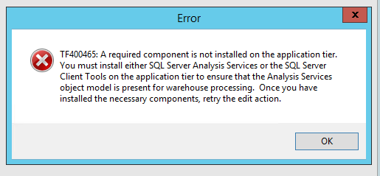

Next Step – install Sql Server Management Studio (SSMS) in tfsprod01

Restarted the TFS App Console.

Click edit again, and get this:

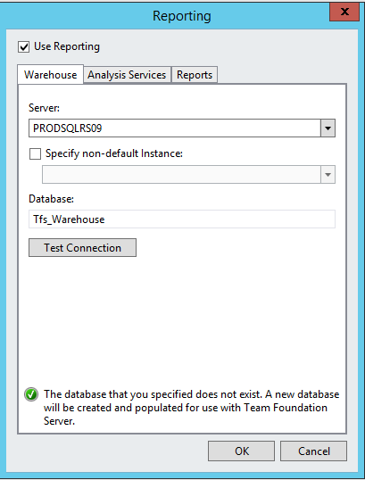

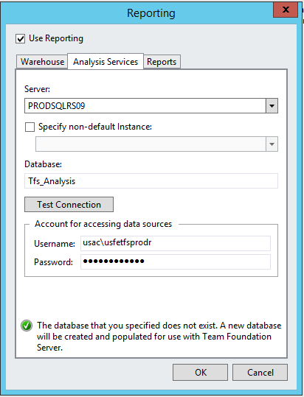

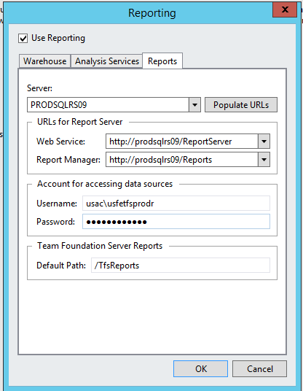

Note – I entered the URLs for Report Server manually – clicking the ‘Populate URLs’ gave the same Access Denied error as the original installation wizard.

Clicked okay and got this:

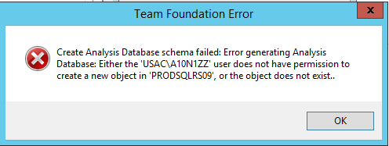

I pinged the DBA, had my usac account added to the admin group on the machine, reentered all the data again, and everything was configured. DBA pulled my account from the admin group.

Done – Reporting and cube processing is now functional.

